Task1-4:

class **Node**{  
  
 int value;  
 **Node** left;  
 **Node** right;  
 public Node(int value){  
 this.value = value;  
 this.left=null;  
 this.right=null;  
 }  
}  
class **Tree**{  
 **Node** root;  
 public Tree(){  
 root=null;  
 }  
 public void insert(int value){  
 root = insertRec(root, value);  
 }  
 private **Node** insertRec(**Node** root, int value){  
 if (root==null){  
 root=new Node(value);  
 return root;  
 }  
 if (value< root.value){  
 root.left = insertRec(root.left, value);  
  
 }  
 else if (value> root.value){  
 root.right = insertRec(root.right, value);  
  
 }  
 return root;  
 }  
 public void inorder() {  
 inorderRec(root);  
 **System**.*out*.println();  
 }  
  
 private void inorderRec(**Node** root) {  
 if (root != null) {  
 inorderRec(root.left);  
 **System**.*out*.print(root.value + " ");  
 inorderRec(root.right);  
 }  
 }  
  
 }  
 public class **Task1to4** {  
 public static void main(**String**[] args) {  
 **Tree** tree = new Tree();  
 tree.insert(3);  
 tree.insert(3);  
 tree.insert(5);  
 tree.insert(2);  
 tree.insert(11);  
 tree.insert(6);  
 tree.insert(20);  
 tree.insert(19);  
 **System**.*out*.println("In-order traversal: ");  
  
 tree.inorder();  
 }  
}

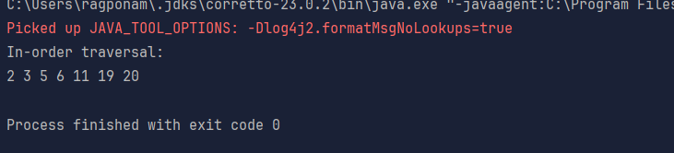

Task5:

Applications of trees:

Hierarchal data representation

Binary search

Syntax trees

Network routing algorithms and spanning trees

Decision making trees

Task6:

class **TreeNode** {  
 int item;  
 **TreeNode** left, right;  
  
 TreeNode(int item) {  
 this.item = item;  
 left = right = null;  
 }  
}  
  
class **BinarySearchTreeOp02** {  
 **TreeNode** root;  
  
 public BinarySearchTreeOp02() {  
 this.root = null;  
 }  
  
 public void insert(int item) {  
 root = insertRec(root, item);  
 }  
  
 private **TreeNode** insertRec(**TreeNode** root, int item) {  
 if (root == null) {  
 root = new TreeNode(item);  
 return root;  
 }  
  
 if (item < root.item) {  
 root.left = insertRec(root.left, item);  
 } else if (item > root.item) {  
 root.right = insertRec(root.right, item);  
 }  
  
 return root;  
 }  
  
 public **TreeNode** search(int key) {  
 **TreeNode** current = root;  
 while (current != null) {  
 if (key == current.item) {  
 return current;  
 } else if (key < current.item) {  
 current = current.left;  
 } else {  
 current = current.right;  
 }  
 }  
 return null;  
 }  
  
 public void inorder() {  
 inorderRec(root);  
 **System**.*out*.println();  
 }  
  
 private void inorderRec(**TreeNode** root) {  
 if (root != null) {  
 inorderRec(root.left);  
 **System**.*out*.print(root.item + " ");  
 inorderRec(root.right);  
 }  
 }  
  
 public static void main(**String**[] args) {  
 **BinarySearchTreeOp02** bst = new BinarySearchTreeOp02();  
  
 **System**.*out*.println("Inserting elements: 50, 30, 70, 20, 40, 60, 80");  
 bst.insert(50);  
 bst.insert(30);  
 bst.insert(70);  
 bst.insert(20);  
 bst.insert(40);  
 bst.insert(60);  
 bst.insert(80);  
  
 **System**.*out*.print("In-order traversal: ");  
 bst.inorder();  
  
 **System**.*out*.println("**\n**Searching for elements:");  
 int searchKey1 = 40;  
 **TreeNode** result1 = bst.search(searchKey1);  
 if (result1 != null) {  
 **System**.*out*.println("Found " + searchKey1 + " in the tree.");  
 } else {  
 **System**.*out*.println(searchKey1 + " not found in the tree.");  
 }  
  
 int searchKey2 = 99;  
 **TreeNode** result2 = bst.search(searchKey2);  
 if (result2 != null) {  
 **System**.*out*.println("Found " + searchKey2 + " in the tree.");  
 } else {  
 **System**.*out*.println(searchKey2 + " not found in the tree.");  
 }  
 }  
}

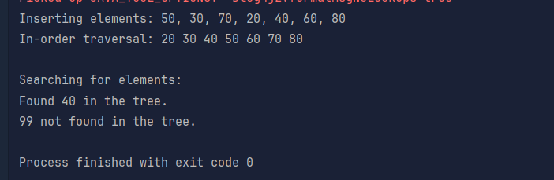

Task7:

Full Binary tree

Complete Binary tree

Perfect Binary tree

Skewed Binary tree

Balanced Binary tree

Task8:

Social Networks

Mapping Navigation

Computer Networks

World Wide Web

Logistics and Supply chain

Scheduling

Resource allocation

Biology and genetics

Chemical structures

Task9:

Undirected graph

Directed graph

Weighted graph

Unweighted graphs

Cyclic Graph

Acyclic graph

Task10:

class **Graph01** {  
 class **Edge** {  
 int src, dest;  
 }  
 int vertices, edges;  
  
 **Edge**[] edge;  
  
 Graph01(int vertices, int edges) {  
 this.vertices = vertices;  
 this.edges = edges;  
  
 edge = new Edge[edges];  
 for(int i = 0; i < edges; i++) {  
 edge[i] = new Edge();  
 }  
 }  
  
 public static void main(**String**[] args) {  
 int noVertices = 5;  
 int noEdges = 8;  
 **Graph01** gObj = new Graph01(noVertices, noEdges);   
  
 gObj.edge[0].src = 1;  
 gObj.edge[0].dest = 2;  
 gObj.edge[1].src = 1;  
 gObj.edge[1].dest = 3;  
 gObj.edge[2].src = 1;  
 gObj.edge[2].dest = 4;  
 gObj.edge[3].src = 2;  
 gObj.edge[3].dest = 4;  
 gObj.edge[4].src = 2;  
 gObj.edge[4].dest = 5;  
 gObj.edge[5].src = 3;  
 gObj.edge[5].dest = 4;  
 gObj.edge[6].src = 3;  
 gObj.edge[6].dest = 5;  
 gObj.edge[7].src = 4;  
 gObj.edge[7].dest = 5;  
  
 for(int i =0; i < noEdges; i++) {  
 **System**.*out*.println(gObj.edge[i].src+ " - " + gObj.edge[i].dest);  
 }  
 }  
}



Home task:

Factorial:

public class **Factorial** {  
 public static int fact(int n){  
 if (n ==0 || n==1)  
 return 1;  
 else {  
 return n\**fact*(n-1);  
 }  
 }  
  
 public static void main(**String**[] args) {  
 int result=*fact*(4);  
 **System**.*out*.println(result);  
 }  
}

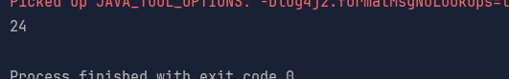

Fibonacci:

public class **Fibonacci** {  
 public static int fibo(int n){  
 if (n<=1)  
 return n;  
  
  
 return *fibo*(n-1)+*fibo*(n-2);  
 }  
  
 public static void main(**String**[] args) {  
 **System**.*out*.println(*fibo*(8));  
 }  
}

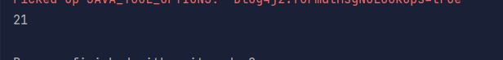

Iteration vs recursion:

Iteration means using loops to repeatedly execute a block of code until a said condition is met. This condition is dependent on the variables in the loop.

Recursion is a technique where a function calls itself to solve a problem. It breaks down complex problems into simpler problems by breaking them into small pieces until it reaches the base case which returns direct and non-recursive solution.

Recursion add itself to the call stack on recurrence making it prone to stack overflow errors whereas iterations do not.

Iterations are memory efficient when compared to recursion.

Iterative solutions are faster to process in comparison.

Recursion offers easier implementations for tree and graph traversals.

Reverse a string:

public class **StringReverse** {  
 public static **String** StrRev(**String** s){  
 if (s == null || s.length()==1)  
 return s;  
 return s.charAt(s.length()-1)+*StrRev*(s.substring(0,s.length()-1));  
 }  
  
 public static void main(**String**[] args) {  
 **System**.*out*.println(*StrRev*("HelloAll"));  
 }  
}

